Company Registration Number 4169017 VAT No 206 2001 33

Mobile Crane Hire Specialist Transport

(C.P.A. Model Conditions) (R.H.A. 1998 Conditions)

J&M Crane & Transport Limited
24 hr Crane & Transport Services

Denton Wharf, Mark Lane, Gravesend, Kent, DA12 2QD
Tel: 0845 2794877 Fax: 0845 2794876

Email: info@jandmcranehire.co.uk
www.jandmcranehire.co.uk
DATE 29 July 2025

To whom it may concern.

Immediate report
Re Vehicle reg LC14JMC
Serial Nr 6601-0134
Policy / Contract Nr NYW39731
Schedule Nr L1

‘The overload limit lights are poor in operation and should be rectified’

Please accept this letter as confirmation that the over load limit lights have been stripped and cleaned.

Yours sincerely,
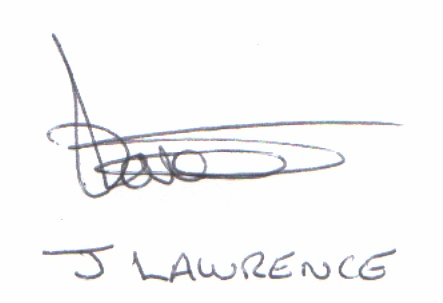

James Lawrence
Managing Director

For and on behalf of J&M Crane & Transport Ltd

