Company Registration Number 4169017 VAT No 206 2001 33

Mobile Crane Hire Specialist Transport

(C.P.A. Model Conditions) (R.H.A. 1998 Conditions)

J&M Crane & Transport Limited
24 hr Crane & Transport Services

Denton Wharf, Mark Lane, Gravesend, Kent, DA12 2QD
Tel: 0845 2794877 Fax: 0845 2794876

Email: info@jandmcranehire.co.uk
www.jandmcranehire.co.uk
DATE 26 May 2025

To whom it may concern.

Immediate report 329025-016
Re crane reg LC17JMC
Serial Nr 7310186
Policy / Contract Nr NYW39731
Schedule Nr L1

Mani hoist rope has been replaced see attached cert.

Auxiliary hoist rope, cut back, terminated and re connected.

Yours sincerely,
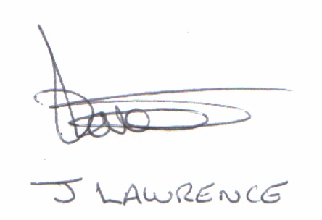

James Lawrence
Managing Director

For and on behalf of J&M Crane & Transport Ltd

